

TechInnovation Website
User Guide
For Exhibitor
Version 1.0

Confidentiality This document contains proprietary information that is confidential to IPI TechInnovation. Disclosure of this document in full or in part, may result in material damage to IPI TechInnovation. Written permission must be obtained from IPI TechInnovation prior to the disclosure of this document to a third party.

Content Page

1. Exhibitor Application Flow 3
1.1 Registration 3
1.2. Login to Portal 3
1.3. Fill in Additional Information 4
1.4. Manage Exhibitors 5
1.4.1 Create New Exhibitor Account 6
1.4.2 Delete Exhibitor Profile 8
1.5 Manage [Team member]s 9
1.5.1 Add [Team member] 9
1.5.2 [Team member] Image and Video 13
1.6 Complete Registration 14

Exhibitor Application Flow

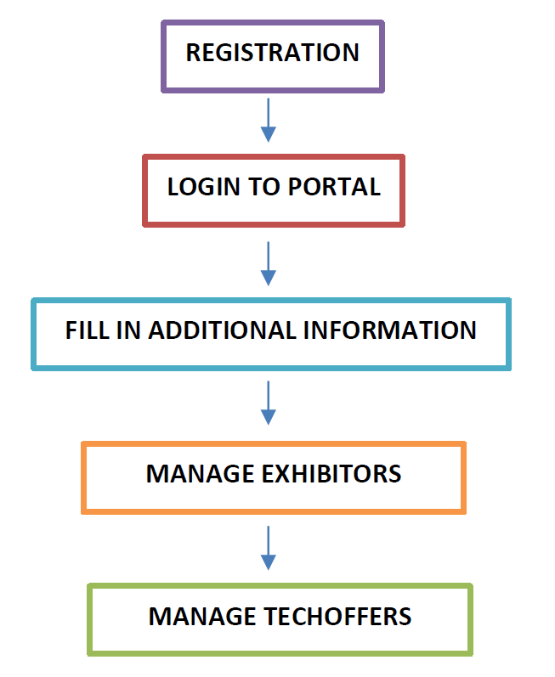

1.1 Registration

To register as TechInnovation exhibitor:
- Go to TechInnovation homepage (http://www.techinnovation.com.sg).
- Click on “Register” on the top right navigation menu.
- Click “Register as Exhibitor” button.
- You will be redirected to application form page.
- Fill all the required fields and click “Submit”.
After submission, IPI staff will assess your suitability. If approved, the system will send email confirmation with login credential to the registered email address.

1.2. Login to Portal

After your application is approved, you may proceed to TechInnovation portal to complete your registration.

To access TechInnovation portal:
1. Go to your confirmation email
2. Click on “Exhibitor Portal”.
3. You will be redirected to portal login page.
4. Log into portal using the credentials sent to your email.

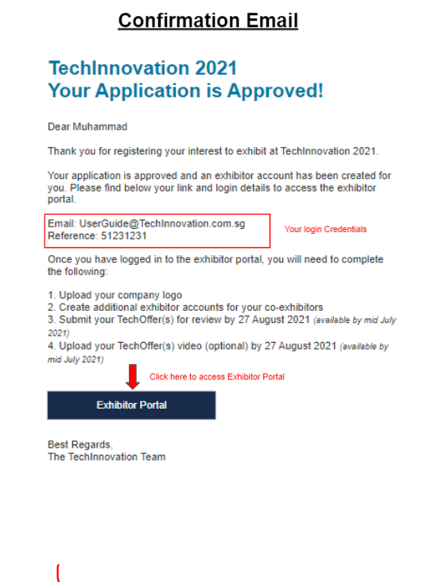
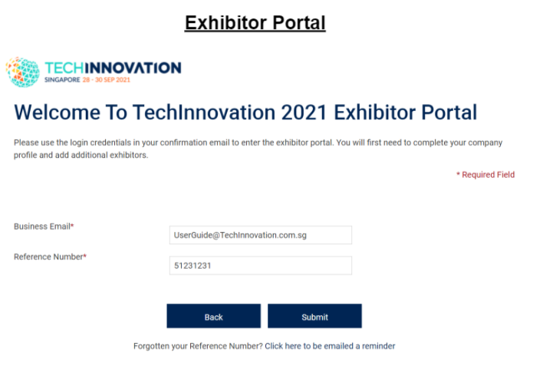

1.3. Fill in Additional Information

You are required to complete this step before you can proceed to Manage Exhibitors and Manage [Team member]s. You are required to:

- Provide organisation name
- This will be displayed on the TechInnovation website, digital booth, and any event collateral.

- Upload organisation logo
- Logo will be used for TechInnovation website, digital booth, and any event collateral.
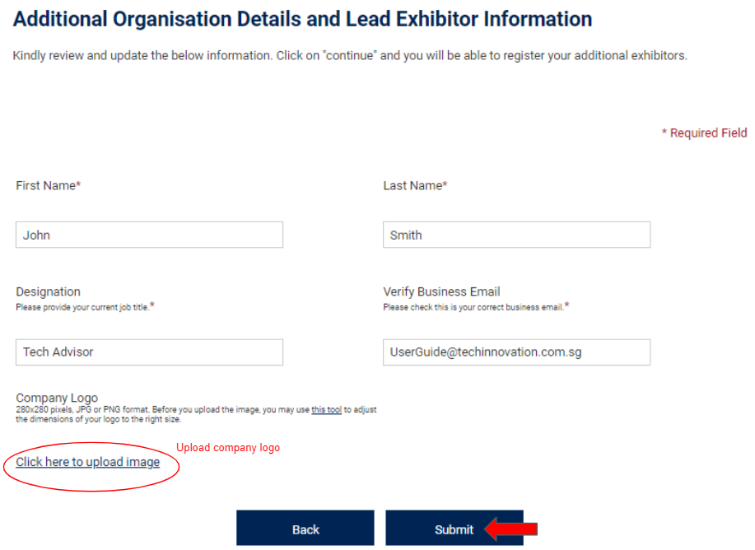

1.4. Manage Exhibitors

There are 2 types of exhibitor account, “Lead Exhibitor” and “Co-Exhibitor”. They have different access rights and permissions. The contact person who submitted the exhibitor application will automatically have Lead Exhibitor rights.

Lead Exhibitor Rights and Permissions

Lead Exhibitors can:
- Edit basic information of the registered organisation such as profile description, country, industry, and technologies to be exhibited.
- Edit additional information of the registered organisation such as organisation logo and video.
- Create and add in regular exhibitor accounts for their organisation.
- Create and manage all [Team member]s that belong to their organisation.
- Create and receive meeting invitations.

Co-Exhibitor Rights and Permissions

Co-Exhibitors can:
- Create, edit and submit [Team member]s with his account as the [Team member] Owner.
- Create and receive meeting invitations.

User Guide Downloads

Guides are available for exhibitors to download for each process.
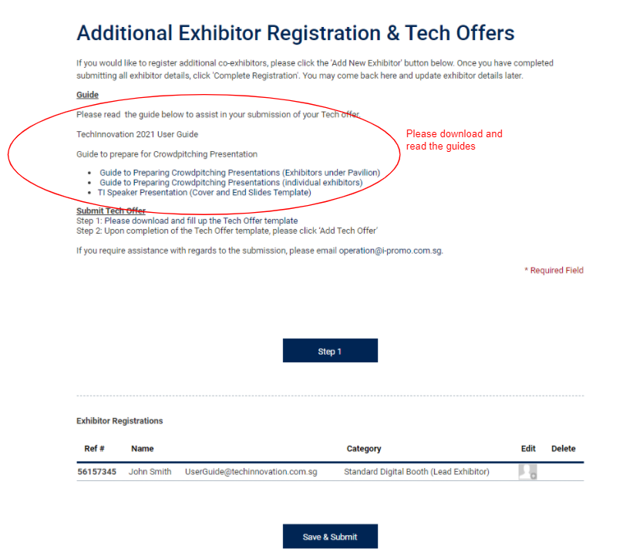

1.4.1 Create New Exhibitor Account

Only the Lead Exhibitor account have the permission to create one (1) new exhibitor account (Basic Package) and up to nine (9) new exhibitor accounts (Standard Package). The Lead Exhibitor account is able to then assign the abovementioned exhibitor rights and permissions accordingly.

To create new co-exhibitor account:
- Go to “Exhibitor Registrations” located at the top banner.
- Click on “Add New Exhibitor” button.

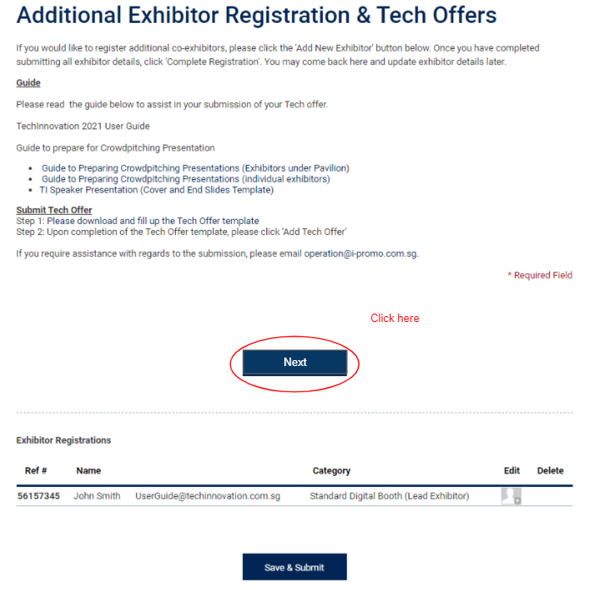
- Fill in required fields and submit.

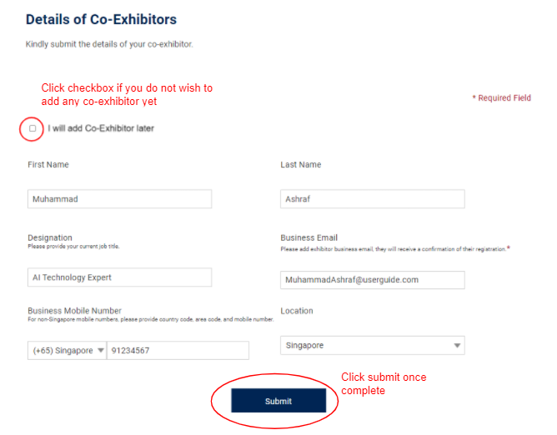
- To add the remaining exhibitors, click ‘Edit’ icon
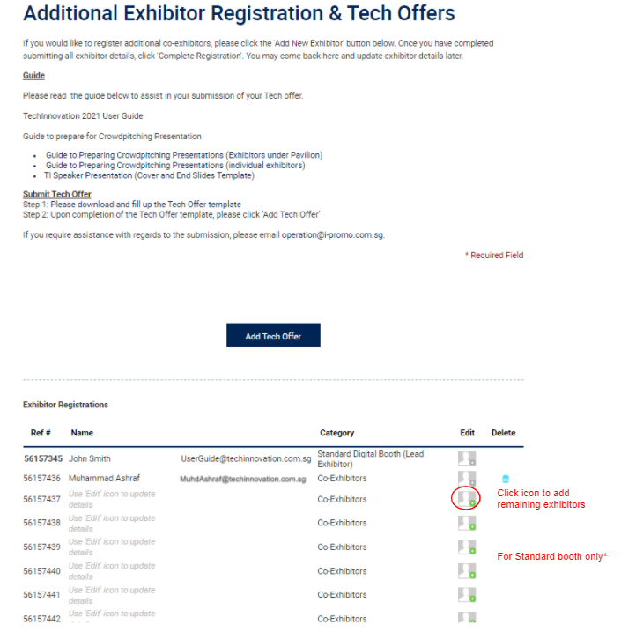

- The co-exhibitor will receive an email notification with the login credentials only when the you have click the “Save & Submit” button.
*You will be able to login into the portal to add the remaining Co-Exhibitor and [Team member] at any time after clicking the “Save & Submit” button.

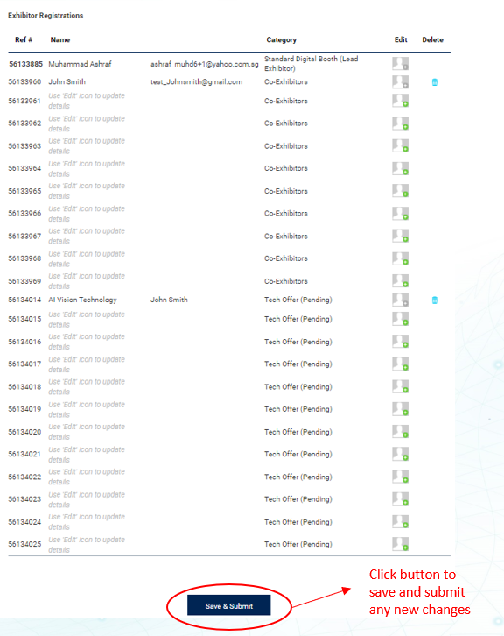

1.4.2 Delete Exhibitor Profile

- Click the trash bin icon to delete exhibitor profile.
*Do take note that once the form has been submitted, the trash bin icon will not be displated. Do contact operation@i-promo.com.sg if you wish to make any changes on the exhibitor profile.
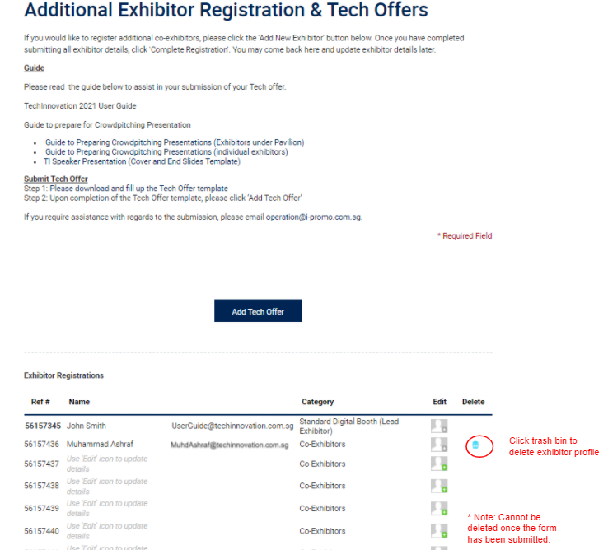

Manage Tech Offers

This section is applicable to all exhibitors taking the Basic Package with up to two (2) [Team member]s or the Standard Package with up to twelve (12) [Team member]s.

Add [Team member]

Lead Exhibitor and co-Exhibitor account users may submit [Team member]s according to their package benefits. Please refer to the guide “TI 2021 Guide on Writing [Team member]s” on how to write a good [Team member]. To create a [Team member]:

- Download and fill in [Team member] template Word Document
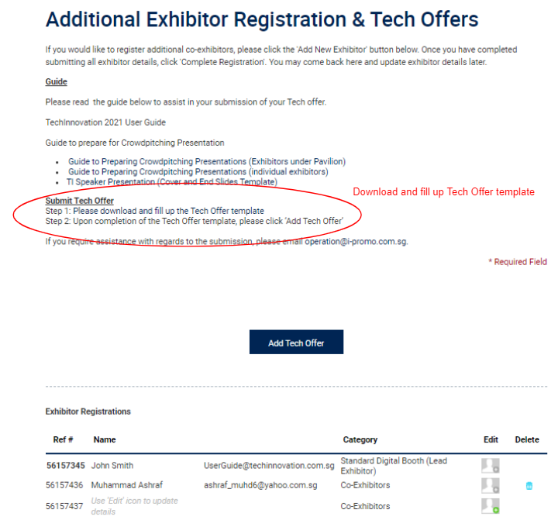

- Fill in the respective form
*Note: Please fill in the [Team member] Word Doc. template prior to submitting the form. There is a time limit of 30 minutes on the submission form due to privacy data regulation.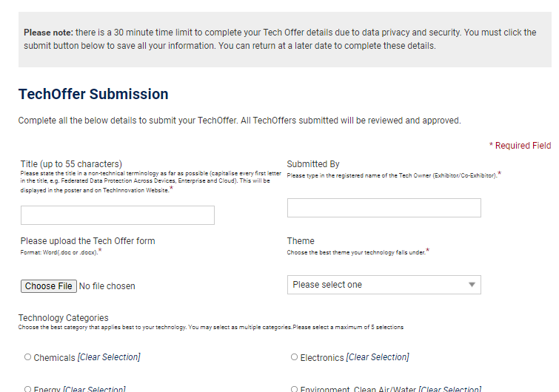

- Fill in Title. The Tech Offer title will be displayed on both the TechInnovation website and the digital booth on the Virtual Platform.
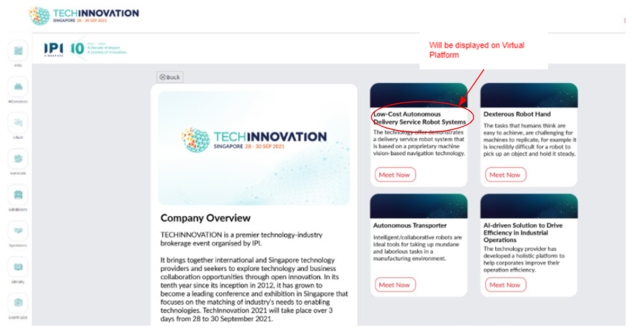

- Submit the email address of the owner of the [Team member].
* The name field must match the names of the registered Lead or Co-Exhibitor. (Case sensitive)
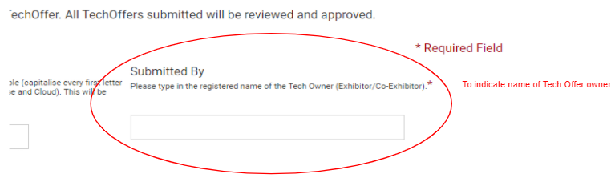
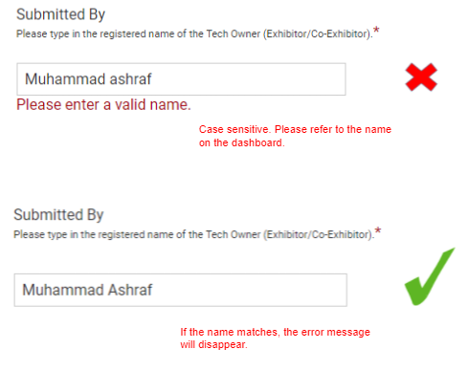
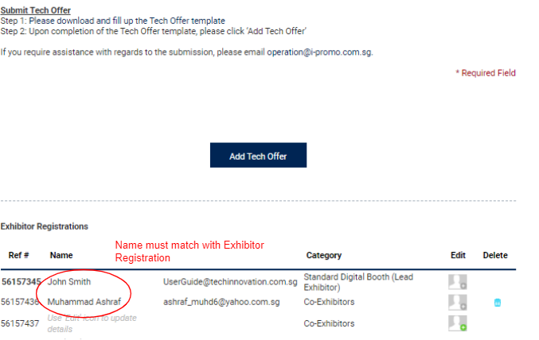

- Abstract/Technology Overview
- This will be displayed on both the website and virtual platform.
Website Abstract Example
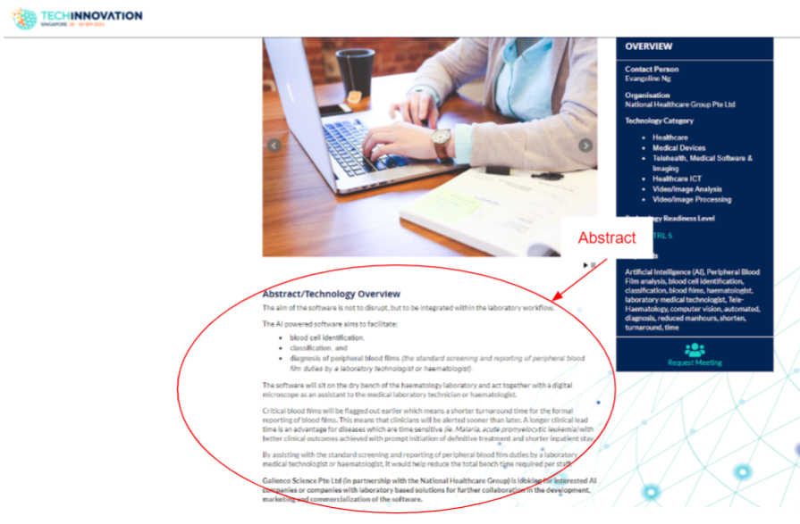
Virtual Platform Abstract Example
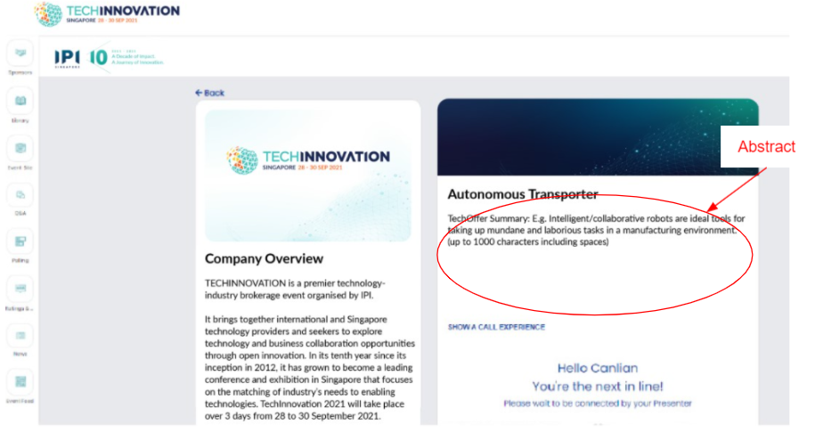

[Team member] Image and Video

Digital page on TechInnovation website
You will be able to include visual aids for the [Team member] displayed on your organisation’s digital page on the TechInnovation 2021 website:
- [Team member] [Team member]
  - 1 to 3 images are allowed to be uploaded for each [Team member]

- Crowdpitching Video Link
  - The Crowdpitching video will be displayed together with the [Team member] details on the website.

Website Header Image Example
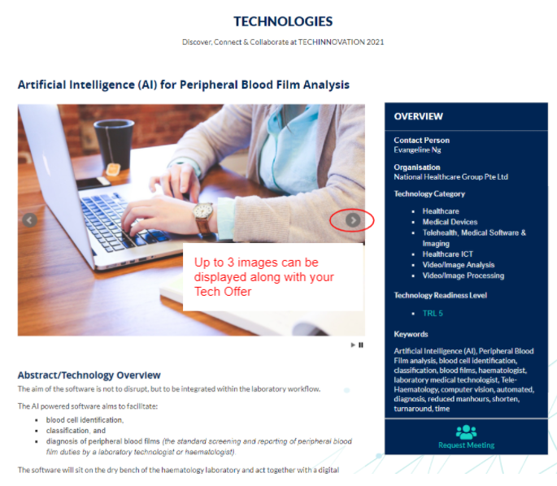

- Upload [Team member] [Team member]

- For TechInnovation 2021 website (750 x 500 pixels). Up to 3 images can be uploaded.

- Submit [Team member] Crowdpitching Video Link (Optional)
- If the video is not ready for submission, another link will be provided through email for you to upload your crowdpitching video once the [Team member] has been approved.

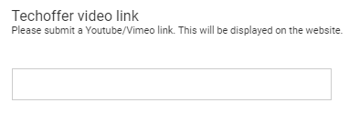

- Fill in the remaining fields.

- Click “Submit”. The [Team member] will be reviewed by our Technology Manager. You will receive a notification email once the [Team member] is approved.

Complete Registration
Click “save and submit” to save the registration of both the newly added Co-Exhibitor and Tech offer.

